35.15: We need to find the positions of the first and second dark lines:
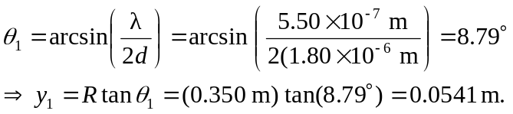
Also 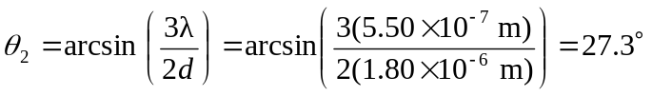
The fringe separation is then

